**Lab Exercise 8– Creating a VPC in Terraform Objective:**

Objective:

Learn how to use Terraform to create a basic Virtual Private Cloud (VPC) in AWS.

Prerequisites:

• Terraform installed on your machine.

• AWS CLI configured with the necessary credentials.

Steps:

Create a Terraform Directory:

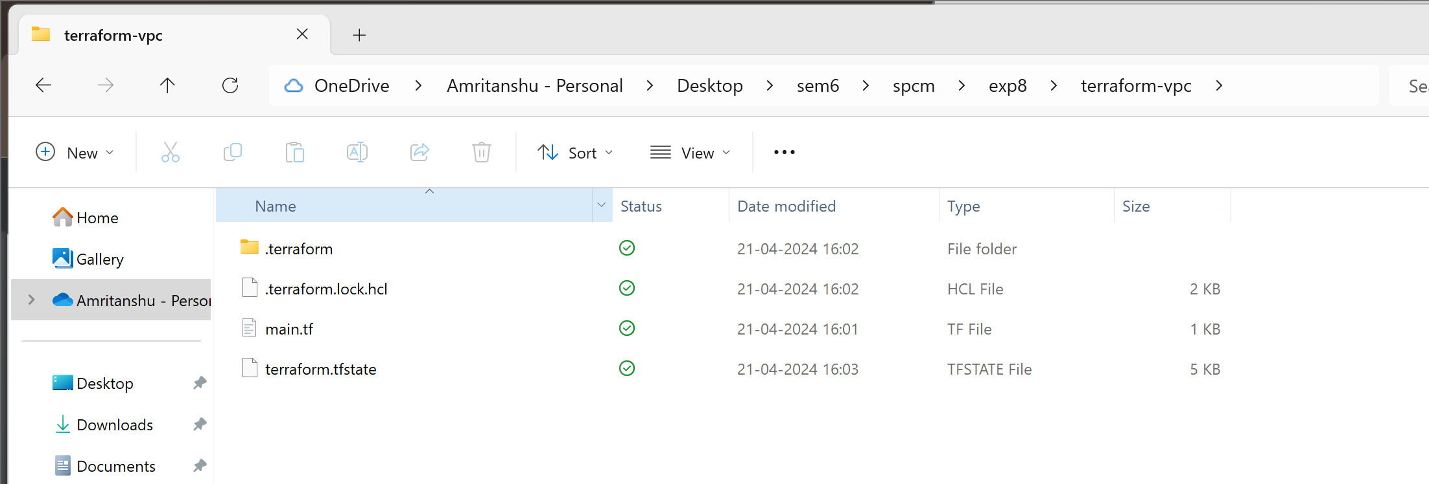

• Create Terraform Configuration Files:

• Create a file named main.tf:

# main.tf

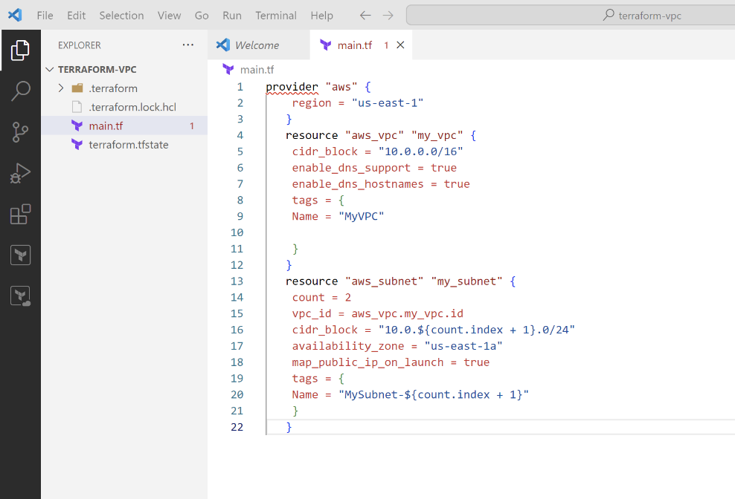

In this configuration, we define an AWS provider, a VPC with a specified CIDR block,

and two subnets within the VPC.

2. Initialize and Apply:

• Run the following Terraform commands to initialize and apply the configuration:

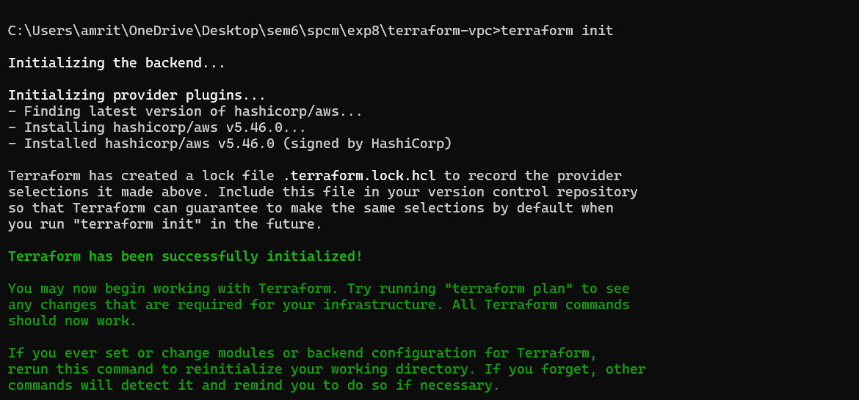

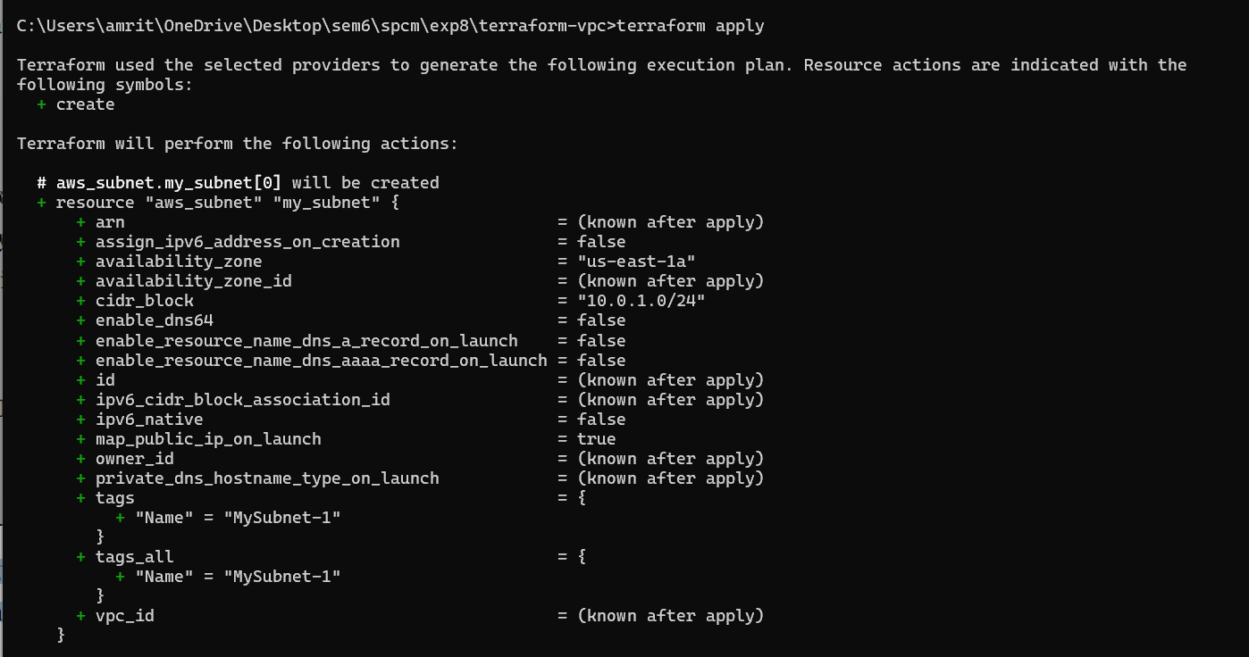

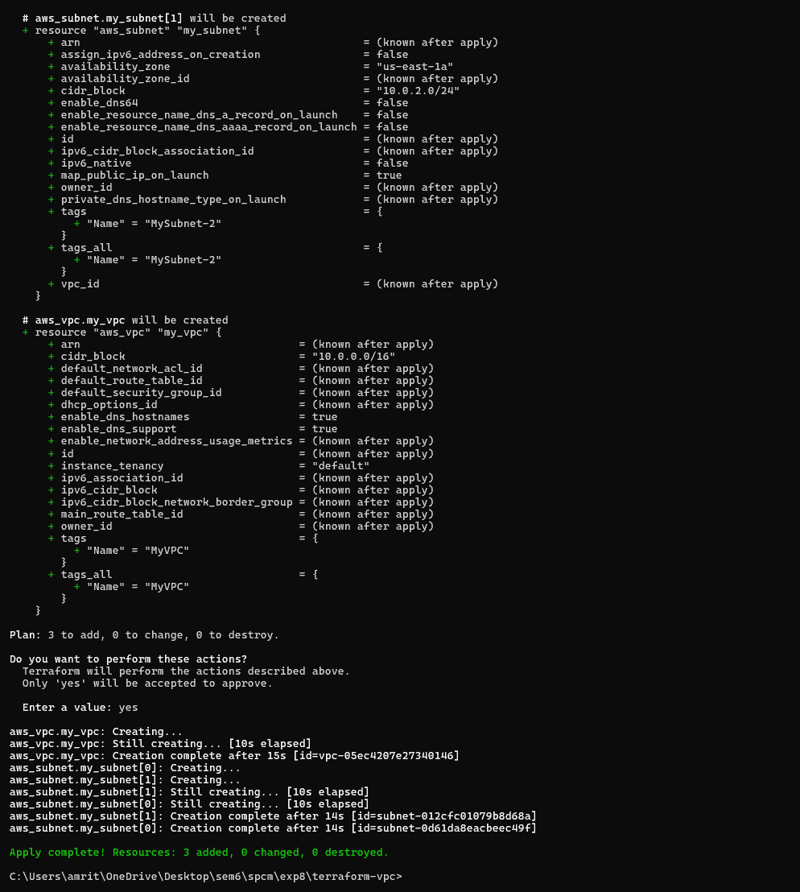

3. Verify Resources in AWS Console:

• Log in to the AWS Management Console and navigate to the VPC service.

• Verify that the VPC and subnets with the specified names and settings have been

created.

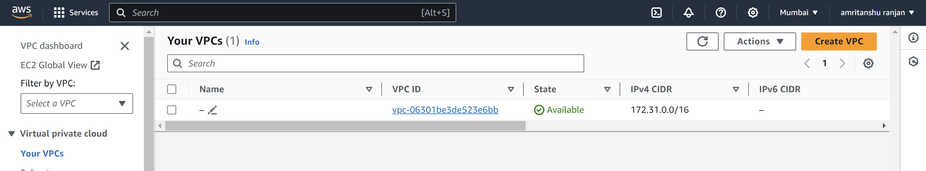

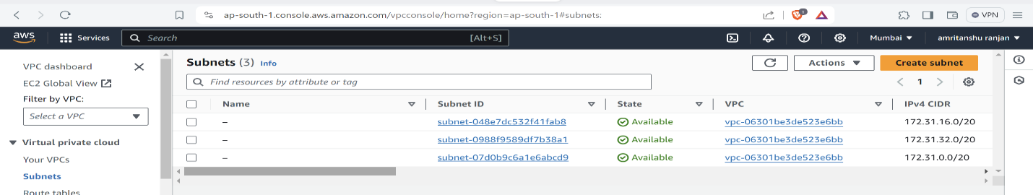

4. Clean Up:

After testing, you can clean up the VPC and subnets:

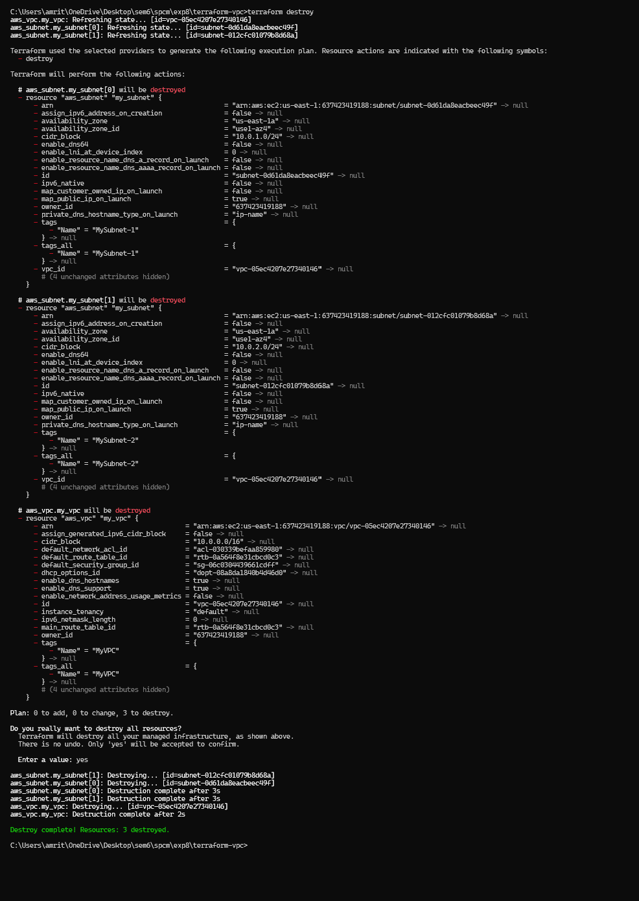

6. Conclusion:

This lab exercise demonstrates how to create a basic Virtual Private Cloud (VPC) with

subnets in AWS using Terraform. The example includes a simple VPC configuration

with two subnets. Experiment with different CIDR blocks, settings, and additional

AWS resources to customize your VPC.